Chapter 7 Smith Exercises & Labs

Exercise 7-1.

1. Describe the error on **line 1** and explain how to fix it.

**ofstream** should be **ifstream**

1. Describe the error on **line 2** and explain how to fix it.

The path inside the parentheses needs double quotation marks

1. Consider the following data from the input file **myDVDFile.dat**:

**Fargo 8.00 1A**

**Amadeus 20.00 2C**

**Casino 7.50 3B**

1. What value is stored in the variable named **dvdName**?

**1A**

1. What value is stored in the variable named **dvdPrice**?

**8.00**

1. What value is stored in the variable named **dvdShelf**?

**Fargo**

1. If there is a problem with the values of these variables, what is the problem and how could you fix it?

**data_in >> dvdName** and **data_in >>** **dvdShelf** should trade places in the code

Lab 7-1.

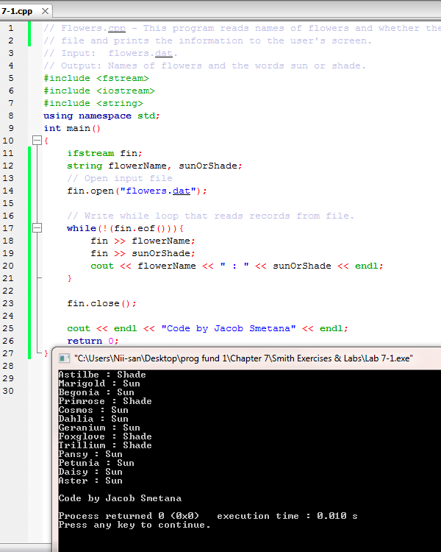

Exercise 7-2.

1. What is the control break variable?

**sectionNum**

1. The value of the control break variable should never be changed. True or false?

False

1. Is **totalSections** being calculated correctly?

Should be **totalSections = 0**

1. In a control break program, it doesn’t matter if the records in the input file are in a specified order. True or false?

False

Lab 7-2 Code.

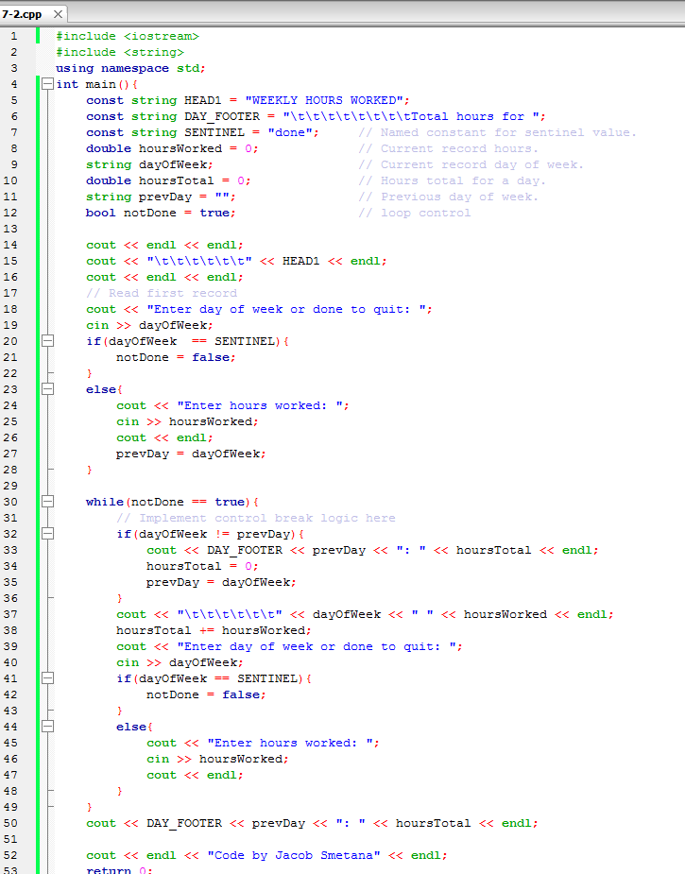

Lab 7-2 Execution.

